Energy Benefit Analysis
of Renewable Energy Sources for Portland Metro Area [Oregon]

Course Title: Advanced Engineering Economics (ETM 535)
Instructor: Dr. Liliya Hogaboam
Term: Spring 2024

Author(s):
Lou Fabino
Yashwanth Dharipelli
Sarang Parthasarathy

Table of Contents
Introduction 3
Objective 3
Oregon’s Renewable Portfolio Standards 3
Project Scope 4
Oregon’s Energy Background 4
Energy Definitions 5
Energy Sources Used in Oregon 6
Wind Energy Background 7
Solar Energy Background 9
Levelized Cost of Electricity (LCOE) 11
Calculation of Projected Energy Consumption 12
Projected Solar Costs 12
Installation Cost 12
Operating Cost 13
Projected Wind Costs 14
Installation Costs 16
Operating Costs 16
Assessment of the Alternatives 17
Alternative 1: 100% Wind 18
Alternative 2: Mix of Wind and Solar 18
Alternative 3: 100% Solar 18
Conclusion 19
Limitations 19
Exclusions 20
References 20
Appendix A 21
Appendix B 21

Introduction
In recent years, there has been a focus on the transition to renewable energy sources for electricity generation. The state of Oregon has implemented multiple renewable energy generation facilities that harvest hydro, wind and solar energy. In the coming years, more renewable energy facilities will be built to meet the needs of the state. This project focuses on assessing Wind, Solar, and a combination of wind and solar to meet those needs.

Objective
The objective of this project is to conduct an energy benefit analysis of the implementation of renewable energy installations (with sources such as Wind and Solar). This project will analyze costs to meet 50% of the 30-year projected energy needs (at year 2054) based on current energy use in Oregon for the Portland Metro area.
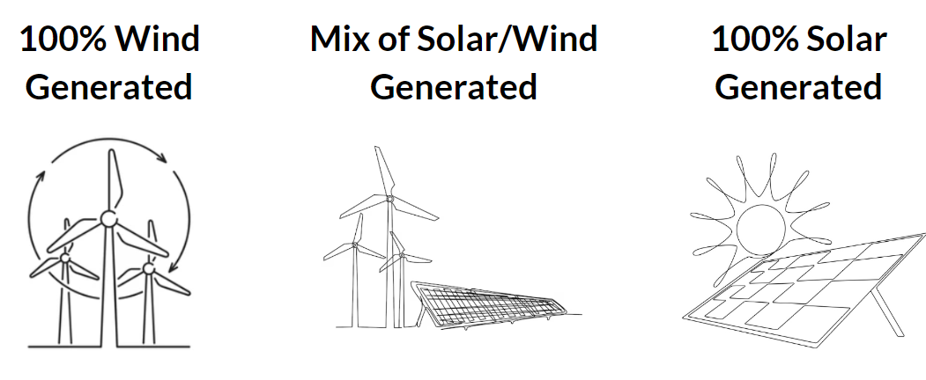
This project will assess three alternatives of energy generation: 100% solar energy facilities, 100% wind energy facilities, and a mix of solar and wind energy facilities.

Figure 1. Types of alternative energy sources considered for this project

Oregon’s Renewable Portfolio Standards
Oregon's Renewable Portfolio Standard requires that 50% of the electricity consumption within the state comes from renewable resources by 2040. To meet this objective, new renewable energy production zones must be planned and established.

Renewable energy makes up an increasingly larger share of the mix each year. In 2021, the State Legislature passed the Oregon Clean Energy Targets Bill. This Bill requires providers such as Portland General Electric, PacifiCorp and electricity service suppliers to reduce greenhouse gas emissions. It also created targets for these companies to reduce the GHG emissions from electricity sold in Oregon to:
- 80% below baseline emissions levels by 2030;
- 90% below baseline emissions levels by 2035; and
- 100% below baseline emissions levels by 2040

Project Scope
- Renewable Energy Options: Evaluate the feasibility and potential benefits of implementing one or more of the following renewable energy sources:
  - Solar Farms
  - Wind Farms
- Geographic Focus: Restrict the analysis to the Portland Metro Area
- Data Collection:
Gather relevant data from energy providers, and other authoritative sources on:
  - Renewable energy potential (solar irradiation, wind patterns) in service areas
  - Existing renewable energy installations and their performance
  - Electricity demand and projected growth
  - Historical data on wind and solar project investments/operations
- Economic Analysis:
  - Initial Investment Costs: Estimate the capital costs for setting up the selected renewable energy installations, including equipment, land acquisition, permitting, and construction.
  - Operational Expenses: Quantify the ongoing expenses for operation and maintenance, insurance, and administrative costs.
- Financial Viability Assessment: Conduct a comprehensive financial analysis using relevant engineering economic techniques, such as Present Worth Method (PW).
- Recommendations: Based on the analysis, provide well-substantiated recommendations for energy providers regarding the implementation of adequate renewable energy generation to meet the portfolio requirements.
By focusing the analysis on energy generation for Portland Metro Area and considering multiple renewable energy options, the adjusted scope remains challenging yet manageable for a three-person team. The emphasis is on leveraging available data sources, conducting a thorough economic analysis, and providing actionable recommendations tailored to the local energy landscape.

Oregon’s Energy Background
Oregon’s energy story has evolved over time to include new technologies, address changes in the availability of different generation resources, and to meet state energy goals.
The Pacific Northwest has a long history of using hydropower resources, but 20 years ago, solar-generated and wind-generated energy sources were scarce.
Today, Oregon’s energy resources are more diverse.

Energy Sources Used in Oregon
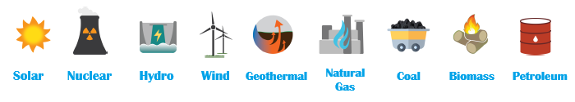
Figure 2. Energy sources used in Oregon

Oregon relies on energy from a variety of resources. Fuel sources like gasoline, natural gas, propane, and other fuels are imported.
Electricity from both in- and out-of-state sources—including coal, natural gas, nuclear, hydropower, wind, and other renewable resources are used.
In 2020, these 4 sectors consumed 983 Trillion BTU of energy combined, including each sector’s electrical system losses. Oregon used 53.7 Million megawatt hours (MWh) of electricity from both in-state and out-of-state sources. Hydropower, coal, and natural gas make up the bulk of Oregon’s electricity resources [1].
In 2022, the breakdown of the total renewable energy consumption (by sector) had an estimate of 247.5 trillion BTU, as follows:
Table 1. Renewable energy consumption by sector
Residential | Commercial | Industrial | Transportation | Electric Power | Total
21.1 | 5.3 | 43.6 | 30.2 | 147.3 | 247.5

Energy Definitions
British Thermal Unit (BTU)
A British Thermal Unit is a measurement of energy. One BTU is defined as the amount of heat required to raise the temperature of one pound of water by one degree Fahrenheit. BTUs are commonly used in the heating and cooling industries to quantify the energy output of heating and cooling systems. They are also used in the energy sector to describe the energy content of fuels.
Conversion: 1 BTU is equivalent to ~1,055 joules, 252 calories, or 0.293 watt-hours.
1 BTU = 0.000293 kWh
10,000 BTUs × 0.000293 kWh per BTU = 2.93 kWh
Megawatt, Megawatthour, Average Megawatt
Megawatt (MW): One million watts of electricity capacity — the equivalent of 1,340 HP (horsepower), or enough power to simultaneously illuminate more than 100,000 standard 60-watt-equivalent LED light-bulbs.
Megawatt-hour (MWh): A unit of measurement for energy output that represents the amount of energy supplied continuously by 1 MW of capacity for one hour.
Average Megawatt (aMW): Represents 1 MW of energy delivered continuously 24 hours per day for one year, or 8,760 MWh.
Figure 3. Energy Use In Oregon
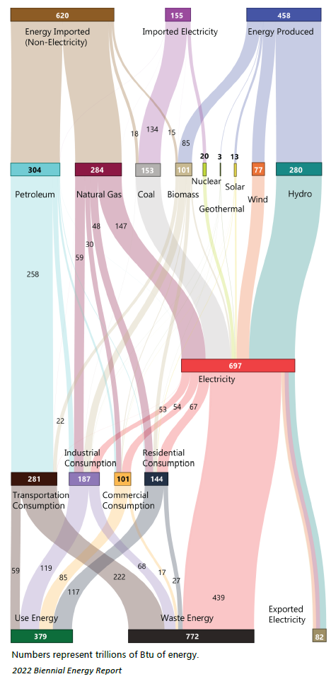
Figure 3 [1] shows the imported energy and energy produced in Oregon. The numbers represent trillions of BTU of energy. The energy lines flow through to show the different types of resources used, including the energy we produce in Oregon and what is imported as direct fuels or electricity. The energy produced and imported helps meet various needs, from in-state electricity generation to transportation fuels to the natural gas and electricity that supply homes and businesses.

Energy Sources Used in Oregon
The following statistics [1] elaborate about the energy sources used in Oregon:
- Between 2012 to 2020, the volume of solar power generation in Oregon has increased from 6,400 MWh to over 1 Million MWh.
- Oregon’s nuclear power comes from Columbia Generating Station in Benton County, Washington and the electricity produced is marketed by the Bonneville Power Administration.
- Oregon has 105 hydropower facilities of varying sizes, including 4 Federal facilities on the Columbia River that span the Oregon-Washington border, and two facilities that span the Oregon-Idaho border.
- As of 2020, Oregon has 54 wind-turbine operating facilities in the state with a total capacity of 4,203 MW.
- Oregon has 2 geothermal electric generation facilities with a capacity of 24 MW.
- There are 13 natural gas electricity generation facilities with a combined capacity of 4,354 MW.
- Oregon has 11 biomass and 30 biogas operating facilities converting waste products to electricity.
- Oregon imports Petroleum that is used in the State.
- Oregon had one coal-fired power plant, the 575 MW Boardman Facility, which closed in October 2020 and was demolished in September 2022.

Wind Energy Background
Wind power is one of the fastest-growing sources of new electricity capacity and the largest source of new renewable power generation added in the United States since 2000. Changes in wind power market dynamics, costs, technology, and deployment since the 2008 DOE report [2] are documented through analysis of recent history, current status (as of 2013), and projected trends. The analysis of wind installation and operational experience as of 2013 concludes that:
- Wind deployment, including associated manufacturing and installation activities, has demonstrated the ability to scale to satisfy rapid build demands, including the deployment levels of the Wind Vision Study Scenario.
- Wind generation variability has a minimal and manageable impact on grid reliability and related costs; and
- Environmental and competing use challenges for local communities, including land use, wildlife concerns, and radar interference issues, can be effectively managed with appropriate planning, technology, and communication among stakeholders.
The U.S. Department of Energy’s (DOE’s) Wind and Water Power Technologies Office led a comprehensive analysis to evaluate future pathways for the wind industry. Through a broad-based collaborative effort, the Wind Vision [3] had four principal objectives:
- Documentation of the current state of wind power in the United States and identification of key technological accomplishments and societal benefits over the decade leading up to 2014.
- Exploration of the potential pathways for wind power to contribute to the future electricity needs of the nation, including objectives such as reduced carbon emissions, improved air quality, and reduced water use.
- Quantification of costs, benefits, and other impacts associated with continued deployment and growth of U.S. wind power; and
- Identification of actions and future achievements that could support continued growth in the use and application of wind-generated electricity.
Wind Vision Study Scenario
The Wind Vision report [3] updates and expands upon the DOE’s 2008 report, 20% Wind Energy by 2030, through analysis of scenarios of wind power supplying 10% of national end-use electricity demand by 2020, 20% by 2030, and 35% by 2050.
This study scenario provides a framework for conducting detailed quantitative impact analyses. The Wind Vision analysis concludes that it is both viable and economically compelling to deploy U.S. wind power generation in a portfolio of domestic, low-carbon, low-pollutant power generation solutions at the study scenario levels. Realizing these levels of deployment, however, would depend upon both immediate and long-term actions—principally identifying continued wind cost reductions, adding needed transmission capacity, and supporting and enhancing siting and permitting activities—to complement any federal, state, tribal, and local policies that may be enacted.
The Wind Vision analysis models three core scenarios in order to better understand the sensitivities in deployment to various external drivers and, subsequently, to understand the likely economic and environmental effects of those drivers on the scenarios.
- a Baseline Scenario, with U.S. wind capacity held constant at 2013 levels of 61 GW;
- a Business-as-Usual Scenario (BAU), and
- a Study scenario.
The BAU Scenario is used to evaluate the industry’s domestic economic competitiveness today and into the future based on central expectations of future fossil fuel and renewable costs, energy demand, scheduled existing fleet retirements, and federal and state policies enacted as of January 1, 2014.
The Study Scenario starts with current manufacturing capacity (estimated at 8-10 GW of nacelle assembly and other large turbine components within the U.S. today) and applies central projections for variables such as wind power costs, fossil fuel costs, and energy demand in order to arrive at a credible projected pathway that would maintain the existing industry, for purposes of calculating potential social and economic benefits.
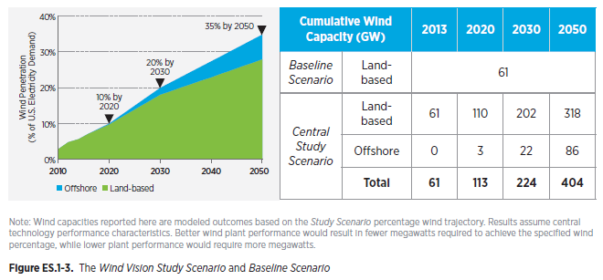Figure 4. Wind Vision Central Study Scenario and Baseline Scenario
The Study Scenario is a plausible outcome, representing what could come about through a variety of pathways, including aggressive wind cost reductions, high fossil fuel costs, federal or state policy support, high demand growth, or different combinations of these factors. The resulting Study Scenario—10% by 2020, 20% by 2030, and 35% by 2050 wind energy as a share of national end-use electricity demand—is compared against the Baseline Scenario to estimate costs, benefits, and other impacts associated with potential future wind deployment.
The wind industry can be characterized by the substantial growth of domestic manufacturing and the level of wind deployment seen in recent years. Wind power systems are now seen as a viable and competitive source of electricity across the nation. Wind power’s emerging role is an important option in a portfolio of new energy solutions for future generations. More than 4.5% of our nation’s electricity came from wind power in 2013, placing the industry at a crossroads between the opportunities of higher energy penetration and the challenges of increased competition, policy uncertainty, access to transmission and lower energy demand.
With about 6% of the nation's electricity supplied by wind energy today, the Department of Energy has collaborated with industry, environmental organizations, academic institutions, and national laboratories to develop a renewed Wind Vision documenting the contributions of wind to date and envisioning a future in which wind continues to provide key contributions to the nation's energy portfolio. Building on and updating the 2008 20% Wind Energy by 2030 [2] report, the Wind Vision report quantifies the economic, environmental, and social benefits of a robust wind energy future and the actions that wind stakeholders can take to make it a reality.
At the end of March 2021, the Biden administration announced efforts to reach 30 GW of offshore wind energy capacity by 2030. This initiative by the current ruling party would support 77,000 jobs, power 10M homes and cut 78M metric tons in carbon emissions.

Solar Energy Background
In September 2021, the US DOE released the Solar Futures Study [3], a report that explores the role of solar energy to drive decarbonization of the U.S. electric grid.
The Solar Futures study explores potential pathways for solar energy to drive deep decarbonization of the U.S. electric grid by 2035, and envisions how further electrification could decarbonize the broader U.S. energy system by 2050. The study is produced by the U.S. Department of Energy, Solar Energy Technologies Office (SETO) and the National Renewable Energy Laboratory (NREL). The study draws on NREL’s decades of solar analysis expertise and was reviewed by an external panel of more than 70 experts.
The study focuses on 3 future scenarios, the assumption for two scenarios is that the U.S. electric grid becomes 95% decarbonized by 2035 and 100% decarbonized by 2050. To achieve these levels of decarbonization, solar would need to account for 45% of electricity generation in 2050 with other zero-carbon energy sources—especially wind energy—supplying the rest.
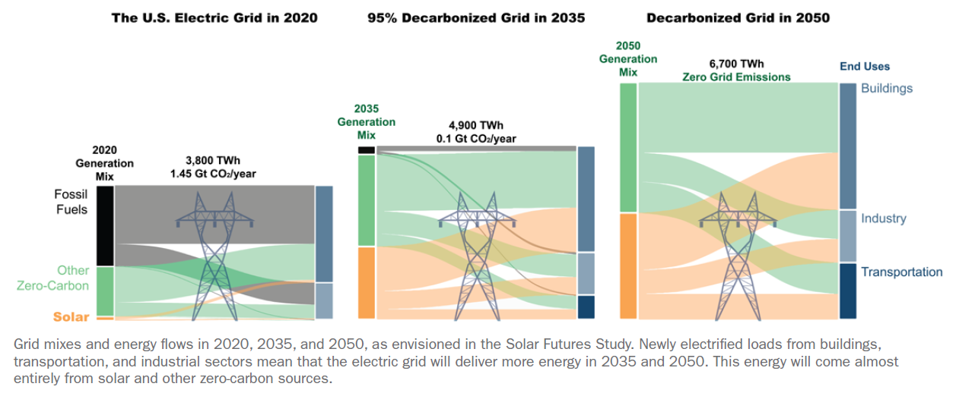
Figure 5. Solar Futures Study Scenarios (for Decarbonization of US Electric Grid)
The study uses a suite of detailed power sector models to develop and evaluate three core scenarios:
- Reference – a business-as-usual future that includes existing state and federal clean energy policies but lacks a comprehensive effort to decarbonize the grid.
- Decarbonization (Decarb) – a future in which policies drive a 95% reduction (from 2005 levels) in the grid’s CO₂ emissions by 2035 and a 100% reduction by 2050.
- Decarbonization with Electrification (Decarb+E) – a future similar to the Decarb scenario that also includes large scale electrification of energy end uses, like buildings and transportation.
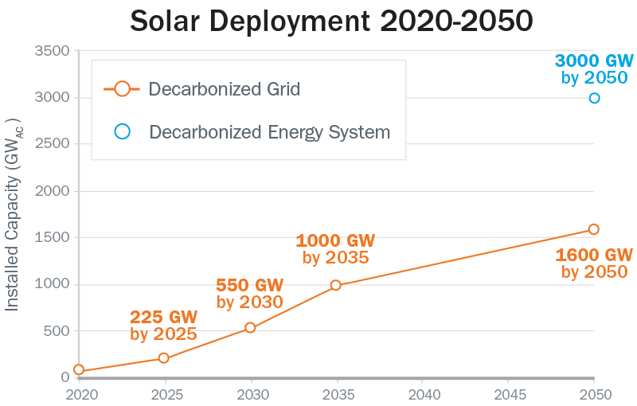
The Solar Futures Study explores solar energy’s role in transitioning to a carbon-free electric grid. The study finds that with aggressive cost reductions, supportive policies, and large-scale electrification, solar could account for as much as 40% of the nation’s electricity supply by 2035 and 45% by 2050.
The Solar Futures Study modeled the deployment of solar necessary for a decarbonized grid. Preliminary modeling shows that decarbonizing the entire energy system could result in as much as 3,000 GW of solar due to increased electrification.
Explore Solar Future Study Data

Figure 6: Solar Deployment forecast (2020 to 2050)
Key Findings of Solar Futures Study
- Solar will grow from 3% of the U.S. electricity supply today to 40% by 2035 and to 45% by 2050. In 2050, this would be supplied by ~1600 gigawatts AC (GW_{AC}) of solar capacity.
- Solar will provide 30% of building energy, 14% of transportation energy, and 8% of industrial energy by 2050, through electrification of these sectors.
- To achieve 95% grid decarbonization by 2035, the US must install 30 GW_{AC} of solar each year between now and 2025 and ramp up to 60 GW_{AC} per year from 2025–2030. The United States installed about 15 GW_{AC} of solar capacity in 2020.
- Through technology advances, a 95% decarbonized grid can be achieved with no impact on 2035 electricity prices.
- The net incremental cost in 2050 of a 100% decarbonized grid, plus further electrification of buildings and transportation, will be ~$210 billion, compared to a reference scenario. Avoided climate damages and improved air quality will result in net overall savings of $1.7 trillion.
- At the levels of growth envisioned in the Solar Futures Study, the solar industry could employ 500,000–1,500,000 people by 2035.

Levelized Cost of Electricity (LCOE)
The levelized cost of electricity (LCOE)^{[4]} is a measure of the average net present cost of electricity generation for a generator over its lifetime. It is used for investment planning and to compare different methods of electricity generation on a consistent basis. The cost of energy production depends on costs during the expected lifetime of the plant and the amount of energy it is expected to generate over its lifetime. The levelized cost of electricity (LCOE) is the average cost in currency per energy unit. The LCOE is an estimation of the cost of production of energy. LCOE “represents the average revenue per unit of electricity generated that would be required to recover the costs of building and operating a generating plant during an assumed financial life and duty cycle”, and is calculated as the ratio between all the discounted costs over the lifetime of an electricity generating plant divided by a discounted sum of the actual energy amounts delivered.
The LCOE is calculated by adding up all costs of production, divided by the total amount of energy it is expected to generate. In formula, LCOE is:
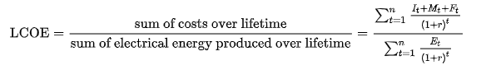
I_{t} = investment expenditures in the year t
M_{t} = operations and maintenance expenditures in the year t
F_{t} = fuel expenditures in the year t
E_{t} = electrical energy generated in the year t
r = discount rate
n = Expected lifetime of system or power station

Calculation of Projected Energy Consumption
Using data and metrics pulled from the US Energy Information Administration [5] for the state of Oregon, we extracted data for Electric Power Capacity, Generation, Supply & Disposition and Sales, Revenue and Average Price for the period from 2011 through 2022.
Then we projected the future energy consumption using data from 2011 to 2022 as follows:
Table 2. Renewable energy projections.
Factors | Avg. Energy Consumption | Future Energy Consumption (20%) | 50% of Future Energy Consumption
Consumption | 60M MWh | 72M MWh | 36M MWh
Capacity | 16,000 MW | 20,000 MW | 10,000 MW
Assuming Portland's needs in 30 years are 20% more than the current average generation, multiply current usage by 1.2. Then we calculate 50% of the energy needs for year 2054 based on these projected needs.
Assuming MARR growth rate of 7% to account for combined rate of inflation, risk rate, rate of return.

Projected Solar Costs

Installation Cost
The cost to install solar consists of the hardware costs and soft costs associated with installing the facility. While hardware costs for solar energy have decreased as photovoltaic technology has matured, soft costs associated with solar facilities have created barriers to enter the market [6]. Solar costs to buy equipment have stabilized in recent years, but the soft cost associated with solar installs have increased.
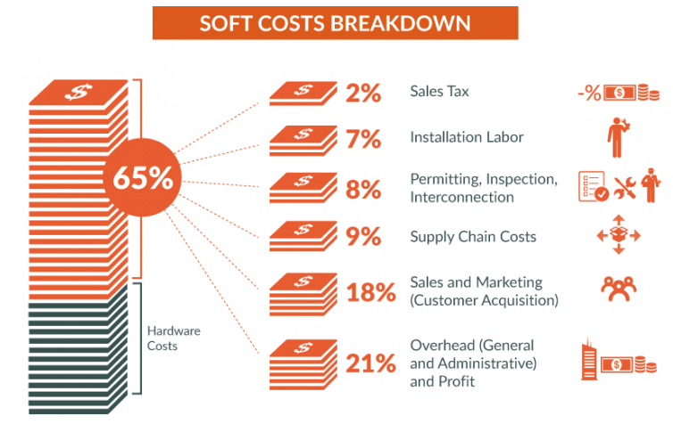
Figure 7: Breakdown of soft costs associated with solar install [6]
Solar Energies Industries Association tracks the overall state of the Solar energy industry in the United States. They have published information about the installation costs associated with solar farms and broken it down by market segment. For Q3 2020 the national average cost for a utility to install solar was $0.95 per MW. In Q3 2021, the cost was $1.01 per MW [7].

To assess the present worth of solar installation in 2024, it was necessary to project the 2021 costs to 2024, this is done with the below calculation, resulting in the values shown in Table 3.
Table 3. Cost of Solar installation projected to 2024 and 2054.
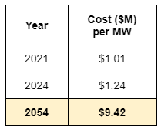

F = P(F/P, i%, n)
F = 1.01 x (F/P, 7%, 33)
F = P x (1 + i)^n
F = 1.01 x (1 + 0.07)^33
F = $9.42

Operating Cost
The operational expenses associated with solar facilities have decreased in the past 20 years [8]. The largest factor in operational expenses is operations and maintenance costs. This includes scheduled & unscheduled maintenance. In 2019, the average OpEx was $17 per kW-yr.
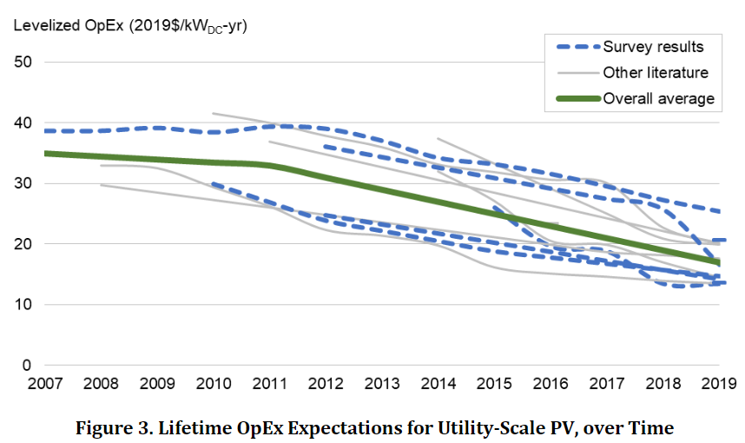
Figure 8: LifetimeOpEx Expectations for Utility Scale PV, over Time [8].

To assess the present worth of solar operations expenses in 2024, it was necessary to project the 2021 costs to 2024. This was done using the following calculation, resulting in the values shown in Table 4.

Table 4. Solar operations cost projected to 2024 and 2054
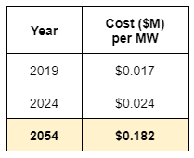

F = P(F/P, i%, n)
F = 0.017 x (F/P, 7%, 35)
F = P x (1 + i)^n
F = 0.017 x (1 + 0.07)^35
F = $0.1815 = $0.182

Projected Wind Costs
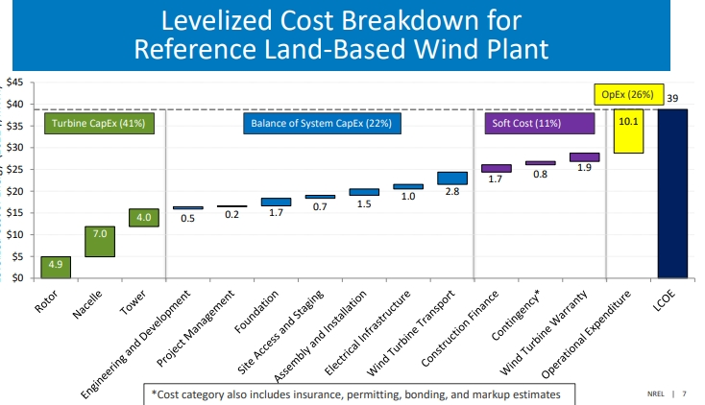
Figure 9:Installation and operational expenses associated with wind land based projects [9].

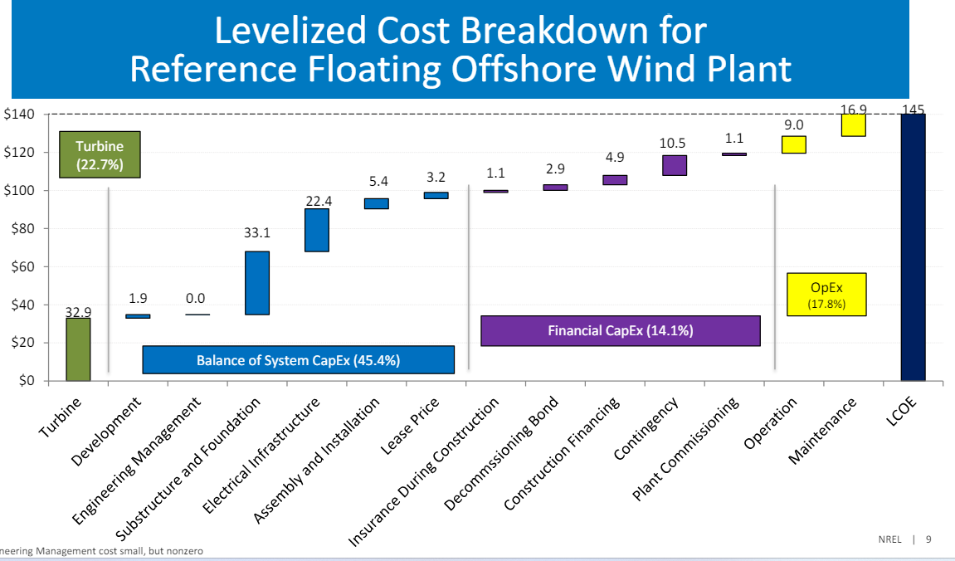
Figure 10:Installation and operational expenses associated with wind Floating based projects [9].

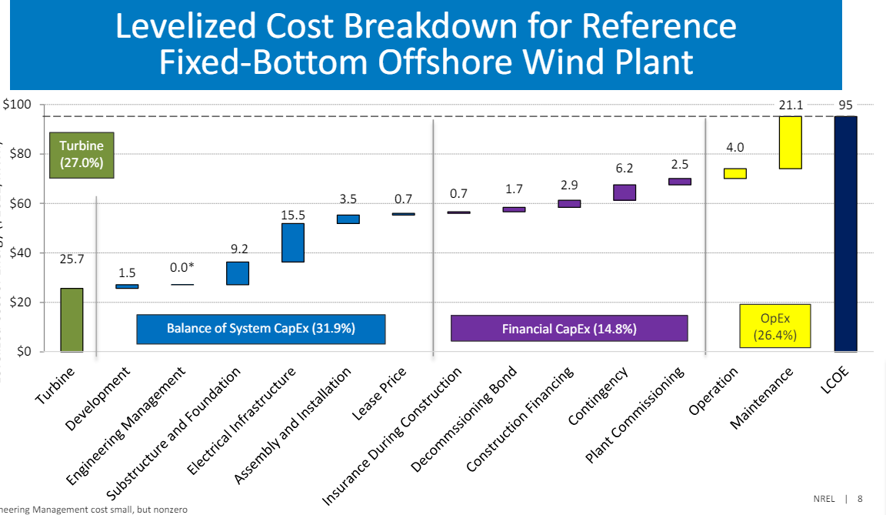
Figure 11: Installation and operational expenses associated with wind Fixed-bottom based projects [9].

Installation Costs
The cost of developing wind power comprises both the hardware costs for the turbines and associated infrastructure, as well as the soft costs which include planning, permitting, and connecting to the grid. Although the hardware costs for wind turbines have significantly decreased due to technological advances and improved manufacturing processes, the soft costs remain a challenge, impacting the overall affordability and expansion of wind energy projects. According to the U.S. Department of Energy, these costs can vary depending on location, scale of the project, and regulatory environment [energy.gov]. For instance, the average installation cost for utility-scale wind projects has seen reductions over recent years, reflecting both improved efficiencies and larger-scale deployment.
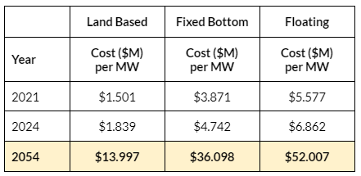
To evaluate the current worth of wind installation in 2054, it was essential to project the 2021 costs forward to 2024. This is accomplished with the calculations detailed below, with the resulting values displayed in Table 5 and 6.

Table 5. Wind installation costs projected to 2024 and 2054

Table 6. Wind installation costs calculation steps
Install Cost (Land-Based) | Install Cost (Fixed-Bottom) | Install Cost (Floating)
F = P(F/P, i%, n)  F = 1.501 x (F/P, 7%, 33)  F = P x (1 + i)^n  F = 1.501 x (1 + 0.07)^33  F = 13.997 | F = P(F/P, i%, n)  F = 3.871 x (F/P, 7%, 33)  F = P x (1 + i)^n  F = 3.871 x (1 + 0.07)^33  F = $36.098 | F = P(F/P, i%, n)  F = 5.577 x (F/P, 7%, 33)  F = P x (1 + i)^n  F = 5.577 x (1 + 0.07)^33  F = $52.007

Operating Costs
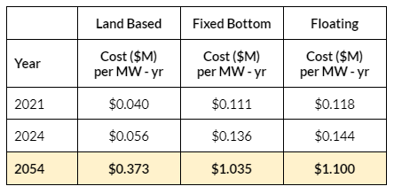
Wind energy operates on natural forces to produce electricity, involving both direct maintenance costs and broader management expenses. While advancements in technology have reduced direct operational costs, management expenses continue to impact the economic feasibility of wind projects, as noted by the U.S. Department of Energy. These costs can vary with the project's location and complexity [energy.gov]. Reports from the American Wind Energy Association (AWEA) indicate a decrease in direct operational costs, but an increase in management expenses, which include system monitoring and community relations.
To evaluate the current worth of wind operating costs in 2054, it was essential to project the 2021 costs forward to 2024. This is accomplished with the calculations detailed below, with the resulting values displayed in Table 7 and 8.

Table 7. Wind operations costs projected to 2024 and 2054

Table 8. Wind operations costs calculation steps
Operating Cost (Land-Based) | Operating Cost (Fixed-Bottom) | Operating Cost (Floating)
F = P(F/P, i%, n)  F = 0.040 x (F/P, 7%, 33)  F = P x (1 + i)^n  F = 0.040 x (1 + 0.07)^33  F = $0.373 | F = P(F/P, i%, n)  F = 0.111 x (F/P, 7%, 33)  F = P x (1 + i)^n  F = 0.111 x (1 + 0.07)^33  F = $1.035 | F = P(F/P, i%, n)  F = 0.118 x (F/P, 7%, 33)  F = P x (1 + i)^n  F = 0.118 x (1 + 0.07)^33  F = $1.100

Assessment of the Alternatives
To assess each of the alternatives, the present worth of each method was calculated. The formula used to calculate the present worth is as follows:
PW = - Installation Costs - Operations Costs + Salvage Costs
For all alternatives, it was assumed that the facilities would have a life of 30 years and there would be no salvage costs in 2054. It was also assumed that all projects would be installed in 2024 and the operational expenses would remain constant for the 30 year projected life.

Alternative 1: 100% Wind
Three technologies were assessed for wind energy generation. The 2024 costs associated with each technology are listed in Table 9. The calculations of the present worth can be found in Appendix A.
Table 9. Cost of wind energy generation in 2024.
2024 Factors | Wind (Land Based) | Wind (Fixed-Bottom) | Wind (Floating)
Install Costs | $1.839 M per MW | $4.742 M per MW | $6.862 M per MW
Operating Costs | $0.056 M per MW-yr | $0.136 M per MW-yr | $0.144 M per MW-yr
Expected Life | 30 years | 30 years | 30 years
Salvage | $0 | $0 | $0
Present Worth (billions) | -$25.3 B | -$64.3 B | -$86.5 B

Alternative 2: Mix of Wind and Solar
Land based wind energy was used to calculate the mix of wind and solar installations. This technology had the lowest present worth, lowest installation cost, and lowest operating cost out of all wind technologies.
To assess a combination of wind and solar, the combined present worth of both technologies was calculated in 10 percent increments. The detailed calculations can be found in Appendix A.
Table 10. Incremental analysis of combined wind and solar installations
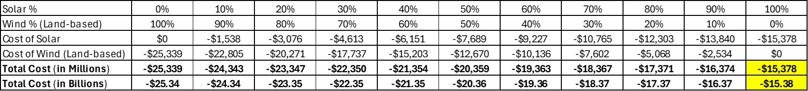

Alternative 3: 100% Solar
Alternative 3 assessed 100% solar energy generation using large scale implementation of photovoltaic panels.The detailed calculations can be found in Appendix A.

Table 11. Cost of solar energy generation in 2024
2024 Factors | Expected Values
Install Costs | $1.24 M per MW
Operating Costs | $0.024 M per MW - yr
Expected Life | 30 years
Salvage | $0
Present Worth (billions) | -$15.4 B

Conclusion
Our analysis reveals significant differences in the cost-effectiveness of various renewable energy installation scenarios. The scenario focusing solely on solar energy emerges as the most economical choice, with a calculated present worth of $15.4 billion. This figure is notably lower than other considered scenarios, highlighting the financial advantage of solar installations.
In contrast, a scenario that exclusively utilizes land-based wind turbines is projected to incur a cost of $25.3 billion. This substantial difference in cost underscores the economic challenges associated with wind energy when compared to solar power under similar conditions.
Furthermore, the analysis of a combined wind and solar energy installation did not present a cost advantage over the 100% solar scenario. This outcome suggests that, within the scope of our financial analysis and current cost structures, a pure solar installation provides the most cost-effective approach to achieving our renewable energy goals.

Limitations
- Pandemic and Global Supply Chain Issues: The ongoing effect of the COVID-19 pandemic and other global disruptions could significantly impact the supply chain for renewable energy technologies. These disruptions might cause delays in project timelines or increase costs unexpectedly, affecting our projected outcomes.
- Technological Advancements: Improvements in renewable energy technologies are anticipated but hard to predict with precision. These advancements could lower installation and operating costs, enhancing economic viability. However, rapid technological changes could also render current models and infrastructure obsolete, introducing a level of financial risk.
- Assumed Growth Rates: Our assumption of a 7% standard growth rate across different energy generation options may not hold true universally. This rate could vary significantly depending on factors such as market demand, government policies, and technological breakthroughs.
- Influence of Climatic and Environmental Factors: Our energy growth projections also assume a 20% increase, which could be impacted by global environmental changes such as global warming and the El Niño and La Niña weather patterns. Moreover, shifts in population dynamics, the increase in electric vehicle (EV) adoption, and other socio-economic factors could either constrain or promote energy consumption differently than anticipated.

Exclusions
- The cost calculations for the alternatives use the Present Worth method for comparisons of different Energy alternatives. Comparisons for future worth, annual worth, etc. were excluded, due to the volume of metrics that we gathered.
- Investor-owned electric resource utility metrics from in-state providers such as Portland General Electric, Pacific Power and electricity partners Idaho Power were assessed. Also, Oregon’s energy use of the Transportation sector − on Zero-Emission Vehicles (ZEVs) was assessed, but both these metrics were not presented to the audience.

References
[1] Oregon Department of Energy, Biennial energy report (https://energyinfo.oregon.gov/ber), accessed 5/23/2024

[2] NREL, Wind energy report (2008), (http://www.nrel.gov/docs/fy08osti/41869.pdf), accessed 5/23/2024

[3] US DOE, Wind Vision report (2015) (https://www.energy.gov/eere/wind/wind-vision-1) and
Wind Vision report (2008) (https://www.energy.gov/eere/wind/20-wind-energy-2030-increasing-wind-energys-contribution-us-electricity-supply), accessed 5/23/2024

[4] Levelized Cost of Electricity (https://en.wikipedia.org/wiki/Levelized_cost_of_electricity) and LCOE Calculators (https://www.nrel.gov/analysis/tech-lcoe.html, https://www.nrel.gov/pv/lcoe-calculator/), 6/6/2024.

[5] US Energy Information Administration, datasets and Oregon state energy metrics (https://www.eia.gov/electricity/state/oregon) 5/23/2024.

[6] Office of ENERGY EFFICIENCY & RENEWABLE ENERGY, Solar Soft Costs Basics, (https://www.energy.gov/eere/solar/solar-soft-costs-basics), 5/20/2024.

[7] Davis, Michelle et al., Solar Market Insight Report 2021 Q4, https://www.seia.org/research-resources/solar-market-insight-report-2021-q4, 5/23/2024

[8] Wiser, R., Bolinger, M., & Seel, J. Benchmarking Utility-Scale PV Operational Expenses and Project Lifetimes: Results from a Survey of U.S. Solar Industry Professionals, https://escholarship.org/uc/item/2pd8608q#author. 5/23/2024

[9] NREL, Tyler Stehly, Patrick Duffy, and Daniel Mulas Hernando, 2022 Cost of Wind Energy Review, December 2023, https://www.nrel.gov/docs/fy24osti/88335.pdf, 5/23/2024

Library Books
- Antonio Luque and Steven Hegedus, Handbook of Photovoltaic Science and Engineering (2nd Edition). Wiley, 2011.
- J.F. Manwell, J.G. McGowan, and A.L. Rogers, Wind Energy Explained: Theory, Design and Application (2nd Edition). Wiley, 2009

Appendix A
See attached Excel spreadsheet.

Appendix B
See attached presentation slides for our Energy Benefit Analysis project.

